NEWTON'S FIRST LAW

A body at rest or moving at constant velocity will continue
to do so unless acted upon by an external unbalanced force.

EXAMPLE
The force needed to move an object appears to be dependent on the mass.
MASS
FORCE

The larger the mass, the greater the force required to move the object.

Newton's First Law is often referred to as the law of inertia.

Inertia is considered to be the property of a body which, when still, makes it hard to move and, when moving, keeps it going.

This property seems to be determined by mass - the greater the mass, the greater the inertia.

EXAMPLE
A train has a lot of inertia due to its large size. It takes a great deal of force to start it moving (if it's stationary) or stop it (if it's moving).

FORCES IN EQUILIBRIUM

Newton's first law states that an object will remain stationary or will move at constant velocity unless there is a nett force acting on it.

i.e. The forces are unbalanced.

Therefore, if the vector sum of all the forces acting on a body is zero, then the body is in a state of equilibrium where the forces balance.

i.e. ΣF = 0

EXAMPLE
A car moving along a straight and flat road maintains a constant velocity of 60.0 kmh⁻¹.

F_{friction}
F_{engine}

Since the car is maintaining a constant velocity, the nett or resultant force is zero.

i.e. ΣF = 0

=> Force due to the engine = Force of friction acting

MOMENTUM

Momentum can be thought of as a measure of how hard it is to stop something that is moving.

e.g. A 1.00 tonne car moving at 10.0 ms⁻¹ is much easier to stop than a supertanker of 1.00 x 10⁵ tonnes moving at the same speed.

The magnitude of momentum is given by:

p = mv

where p = the momentum of the object (kgms⁻¹)
m = the mass of the object (kg)
v = the velocity of the object (ms⁻¹)

NOTE
Momentum is a vector and requires a direction to be given.

An object which changes velocity will change its momentum. This change in momentum is given by:
Δp = p_{final} - p_{initial}
= mv - mu
= m(v-u)

∴ Δp = mΔv

where Δp = the change in momentum (kgms⁻¹)
Δv = the change in velocity of the object (ms⁻¹)

EXAMPLE
A young girl practises her tennis by hitting a ball against the practice wall at Carine open space. The 85.0 g ball strikes the wall at 35.0 ms⁻¹ and bounces off at 25.0 ms⁻¹. Calculate:

(a) the change in velocity of the ball.
(b) the change in momentum of the ball.

(Assume all velocities are horizontal to the ground just before and after impact.)

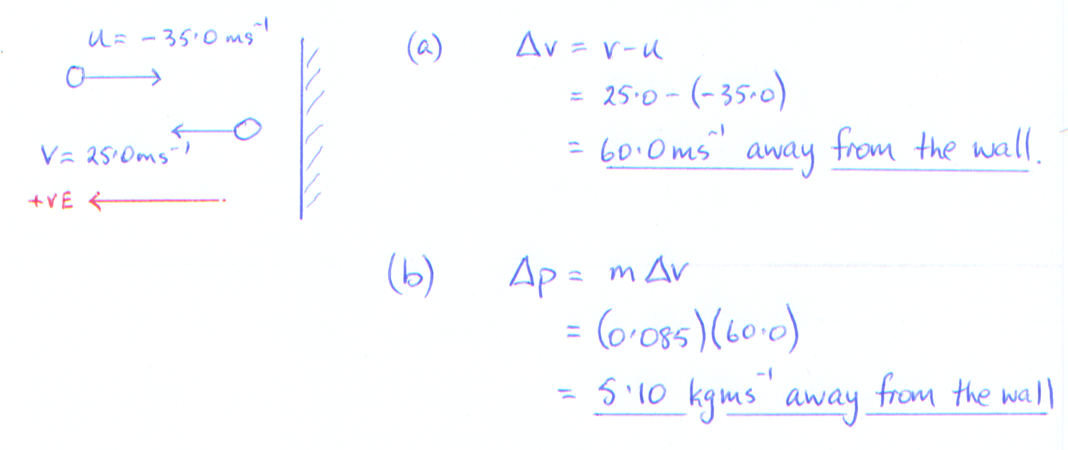
NEWTON'S SECOND LAW

The time rate of change of momentum of a body is directly proportional
to the magnitude of the applied resultant force and is in the direction of
that resultant force.

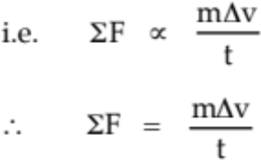

where ΣF = the sum of all forces acting on the body (N)
(i.e. the resultant force)

Given that a = Δv/t :
ΣF = ma

where a = acceleration of the body in the direction of the
resultant force (ms⁻²)

EXAMPLE
A car of mass 1.10 x 10³ kg is accelerated by a motor which provides a force of 3.10 x 10³ N. A frictional force of 8.50 x 10² N opposes the motion of the car. Calculate the acceleration of the car across the ground.

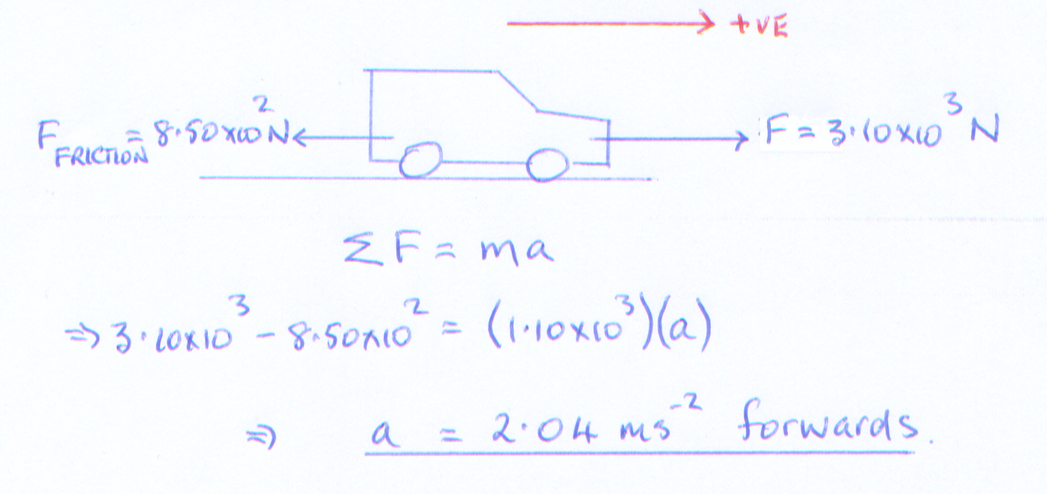
The equation for Newton's second law can be written as:

Ft = mΔv
By definition:

The impulse affecting an object is given by the product of the force acting
and the time taken for the force to act.

i.e. I = Ft

where I = the impulse experienced by the object (Ns)
F = the impulsive force acting (N)
t = the time taken for the force to act (s)

Combining the equations covered thus far gives the following.

I = Ft = mΔv = Δp

*** This is the best equation to remember and use! ***

EXAMPLE 1
During a game of baseball, a batter strikes a ball thrown at him at 35.0 ms⁻¹. It leaves the bat at 55.0 ms⁻¹ after a contact time of 0.116 s. Given that the ball has a mass of 145 g, calculate:

(a) the change in velocity of the ball.
(b) the impulsive force acting.
(c) the impulse experienced by the ball.
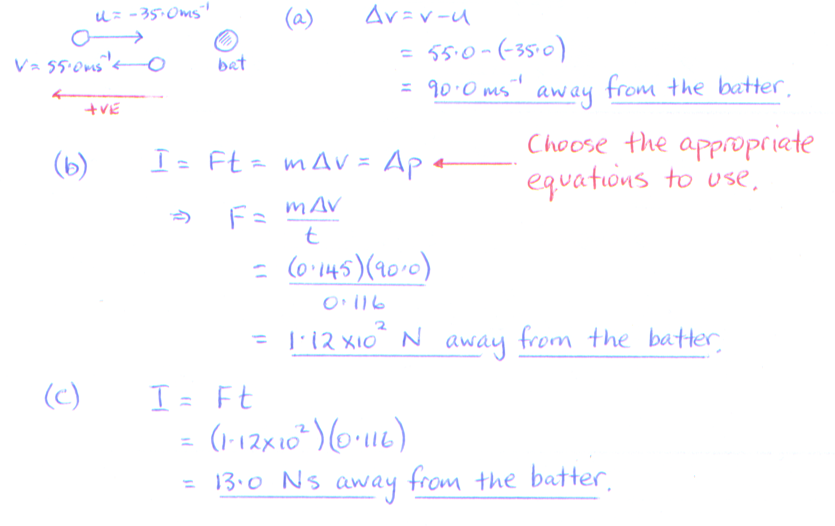
EXAMPLE 2 - AIR BAGS
Air bags are designed to protect the occupants of cars during collisions.

As seen previously: F = mΔv/t = Δp/t

The head and body of a person will undergo a change in momentum (Δp). The value of Δp can be considered constant - it is determined by the speed of the car at impact.

The air bag increases the time for Δp to occur. Thus the force (F) experienced by the person is smaller.

The greater the time taken for the collision to occur, the smaller the forces experienced by the occupants.

OTHER APPLICATIONS
• Crumple zones in cars - these collapse in a controlled fashion. The change in momentum of the car occurs over a longer time so the forces experienced are smaller.

• Sport shoes - soft soles and "gel" increase the contact time of the foot with the ground.

• Stunt bags / high jump bags / etc - all designed to collapse or deform in a uniform manner. Again the time for Δp to occur is increased.

• Sand / rubber around children's playgrounds - contact time with the ground is increased when a child falls from the equipment.

During a collision between two objects, the forces applied are not uniform. By graphing the change in F with time t, the area under the graph gives the value of the impulse (I).

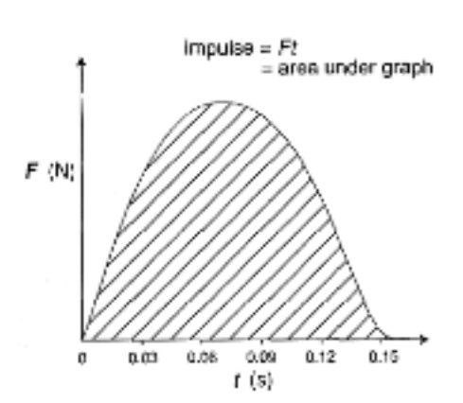

NEWTON'S THIRD LAW

For every action there is an equal and opposite reaction.

Newton realised that forces occur in pairs and act on different objects.

e.g. Consider a block sitting at rest on a table.

The force due to gravity (weight) acts downwards on the block. Thus the block exerts a force onto the table.

The table exerts an equal and opposite force to support it. The table exerts a force onto the block.

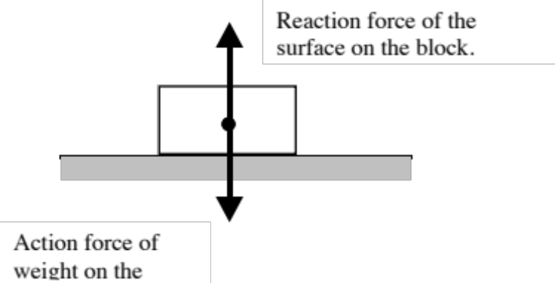

EXAMPLES
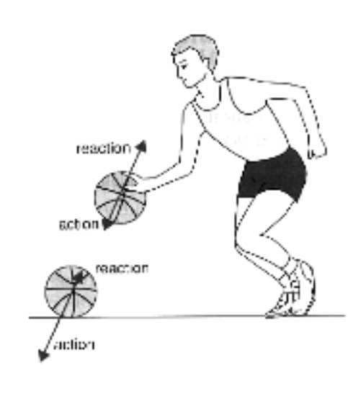
The player pushes on the ball (action) and the ball pushes back equally on his hand (reaction).

When the ball hits the ground, the ball pushes on the ground (action) while the ground pushes back equally (reaction).

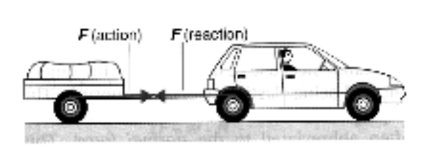
The car pulls on the trailer (action) and the trailer provides a reaction force on the car.

APPARENT WEIGHT

When a person stands still on the ground, the weight they feel through their feet is equal to the reaction force exerted by the ground onto them.

This reaction force is called the apparent weight. In this case the person’s apparent weight is equal to their real weight.
F_{w}
R

When more than one force acts on a body, the resultant force is found as follows.

RESULTANT FORCE = FORCES IN SAME DIRECTION - FORCES IN THE OPPOSITE

AS THE NETT ACCELERATION DIRECTION

EXAMPLES

1. In the situation given above, the nett acceleration of the person is zero.

i.e. ΣF = 0

Take down as positive.

ΣF = F_{w} - R = 0

=> R = F_{w}

∴ The apparent weight = the real weight.
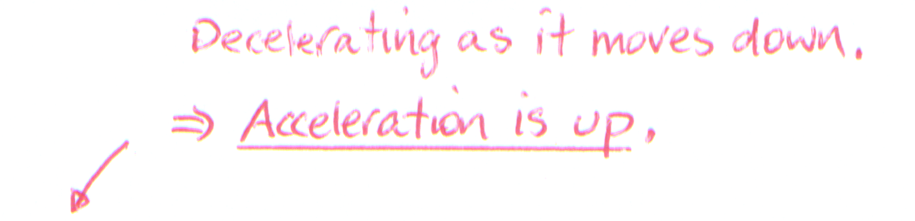
2. LIFT PROBLEMS

(a) A girl of mass 50.0 kg is in a lift which is decelerating at 1.50 ms⁻² as it nears the floor she has selected. What is the girl's apparent weight during this time?

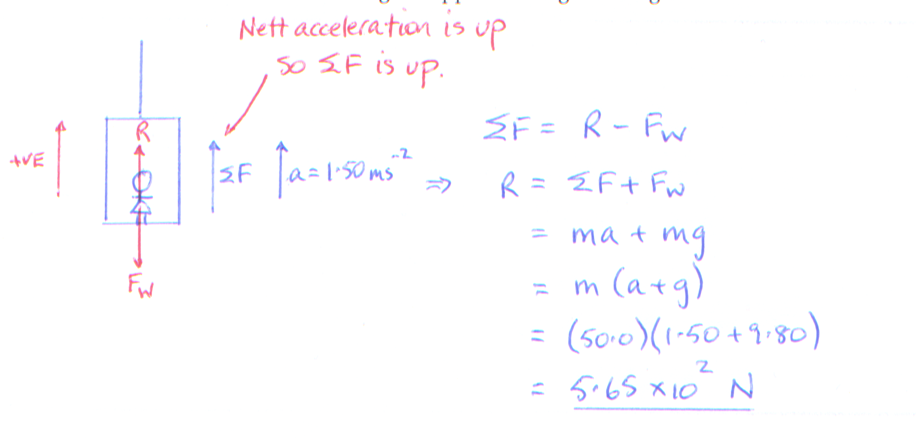

(b) The combined mass of the lift is 2.30 x 10³ kg. What is the tension in the cable if the lift is accelerating at 2.40 ms⁻² upwards as it rises from the basement?

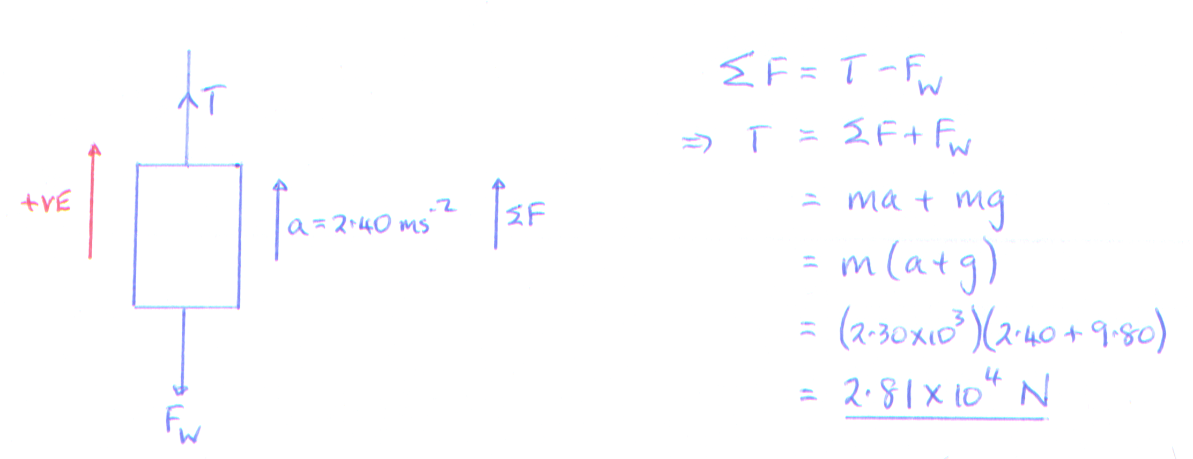
(c) A man of mass 80.0 kg is stuck on a ledge in a cave some 6.00 m above the cave floor.
He has a rope which can only support a mass of 30.0 kg before it breaks.

He can use the rope to slide down to the floor if the rope is attached to the roof of the cave. Justiy this by calculation.

